Electronics Subsystem Member in MotoManipal Monthly Report for October 2023

Anish V R

EPT  
Motomanipal

**Abstract** — This report briefly has insights into the developments done in the Electronic subsystem by Anish in MotoManipal. It comprises of a detailed report for the month of October.

This month, in my work, I've been focusing on building the basic architecture for a Battery Management System (BMS) with active balancing capabilities in SIMSCAPE. My primary objective has been to simulate and gain a deep understanding of the switching frequency of the MOSFETs within the BMS. In this model, I've been working on the implementation of Switching Capacitors, a crucial technique for the active balancing of battery cells.

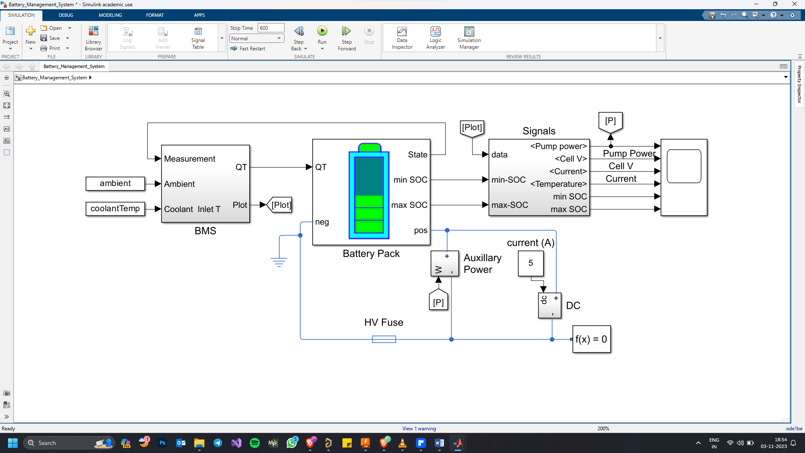

1.BASIC BMS SIMULATION IN SIMSCAPE

Through my simulations, I've generated SOC % vs. time graphs. These graphs offer valuable insights into how the State of Charge (SOC) of individual cells in the battery pack evolves over time. While I've made progress in this area, I recognize that there's still room for improvement in the simulation of the Active Balancer, and I'm committed to refining the model for more accurate and reliable results.

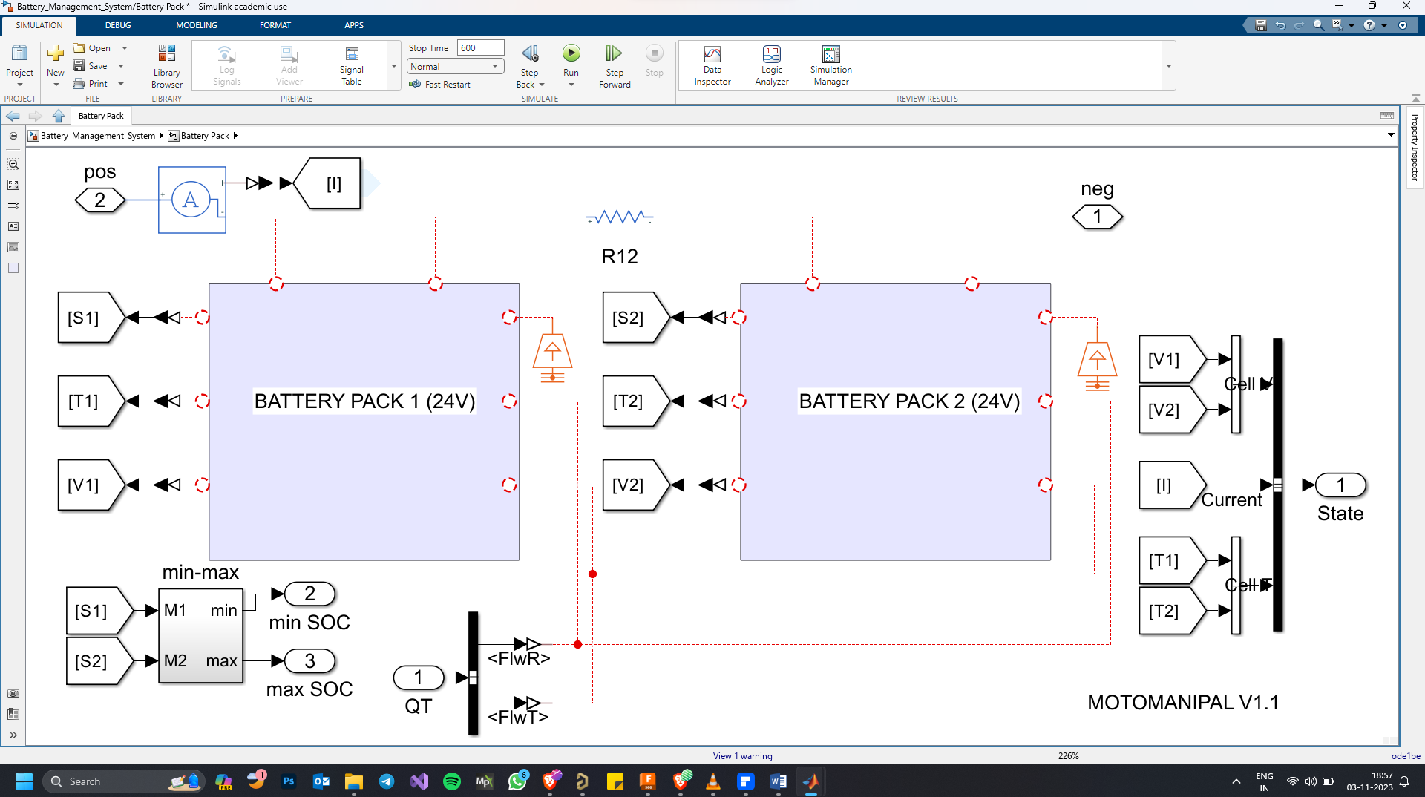

2. MODULAR BATTERY PACK SIMULATION FOR THE UPCOMING DESIGN

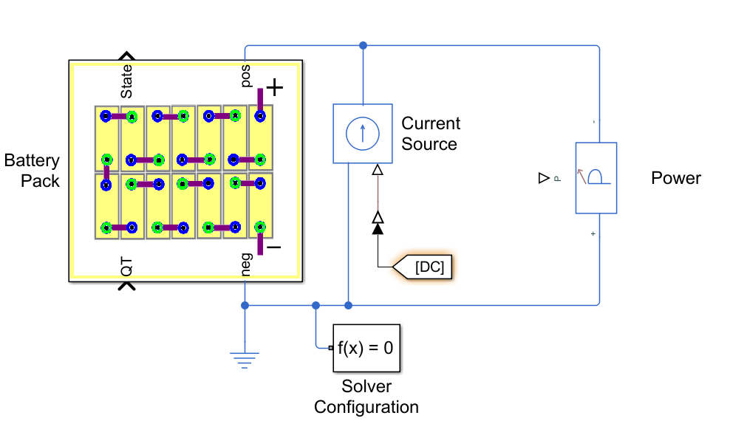

3. RECENTLY STARTED SIMULATION CELL CONFIGURATIONS IN SIMSCAPE AND WOULD WORK ON THE THERMALS

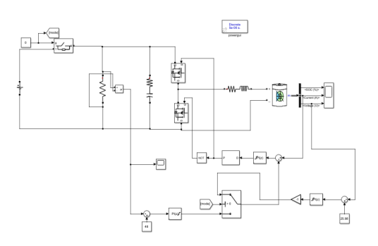In addition to my work in SIMSCAPE, I've been delving into research on Quasi Resonant Buck Converters (QRC). This research is aimed at gaining a better understanding of these converters and their potential applications in my BMS project. To supplement this research, I've also conducted practical simulations of QRCs in Multisim, a hands-on approach that enhances my understanding of these converters and their operational principles.

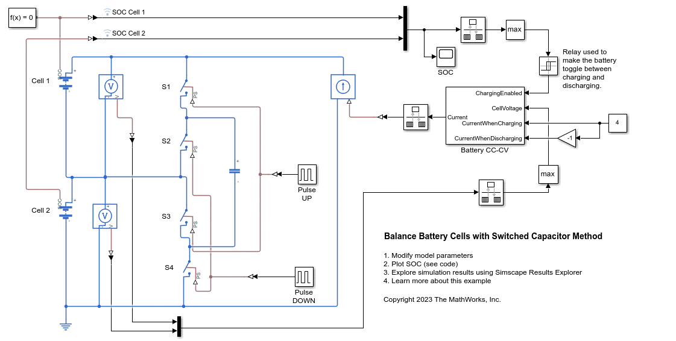In summary, this month has seen me dedicated to the development of an active balancing BMS in SIMSCAPE, with a strong emphasis on comprehending and optimizing the switching frequency of MOSFETs. My work involves experimenting with Switching Capacitors, conducting simulations, and exploring related research on QRCs to enhance my knowledge and ultimately refine my BMS model for improved performance and effectiveness.

**New Modular Battery Pack:**

After a series of calls with the battery manufacturer in Bangalore and continuous requirement list from our side. I felt that it is better we must work on the battery totally from our side than just telling them the needs.

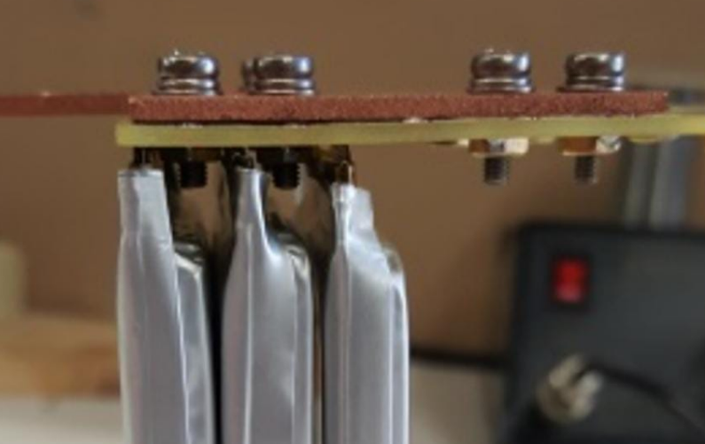So I sat with Santosh (Andaman) by deciding the cell organizing and cell selection (Pouch cell ) and had to make a separate enclosure for each pouch cell because there is a compression guide for the pouch cell battery pack and in this new battery pack my idea is to use the same cells for 24V/48V and that too for 30Ah/60Ah by using the same cells but by changing the PCB BUSBAR which is being designed by me.

**IMAGE: 6**

This Custom PCB Busbar will be placed over the cells and screwed. But I am facing a serious of issues regarding deciding the Trace width. So I planned to add copper sheet with 4mm manually over the PCB after getting the PCB from the manufacturer so that we can reduce the EMI and amount of copper oz we use (REFER IMAGE: 6 )

In my recent work, I've also taken on the task of designing a Printed Circuit Board (PCB) for our new Modular Battery Pack project. This PCB serves a critical role in our battery management system (BMS) setup.

The design of this PCB is quite sophisticated, as it involves multiple layers, specifically a 4-layered PCB configuration. The objective here is to create an optimized PCB structure that will facilitate the integration of two separate 24V battery packs into a single system, essentially treating them as a unified Battery Accumulator.

To achieve this, I've worked on the connections between the BMS and the battery packs. The JST wires from the BMS have been linked to IDC connectors. This setup allows for seamless integration and efficient data transfer between the BMS and the battery packs.

Moreover, I've incorporated voltage and current sensors into the design. These sensors are pivotal for monitoring and reading the data from the two distinct 24V battery packs. This data will be crucial for effective management and performance optimization.

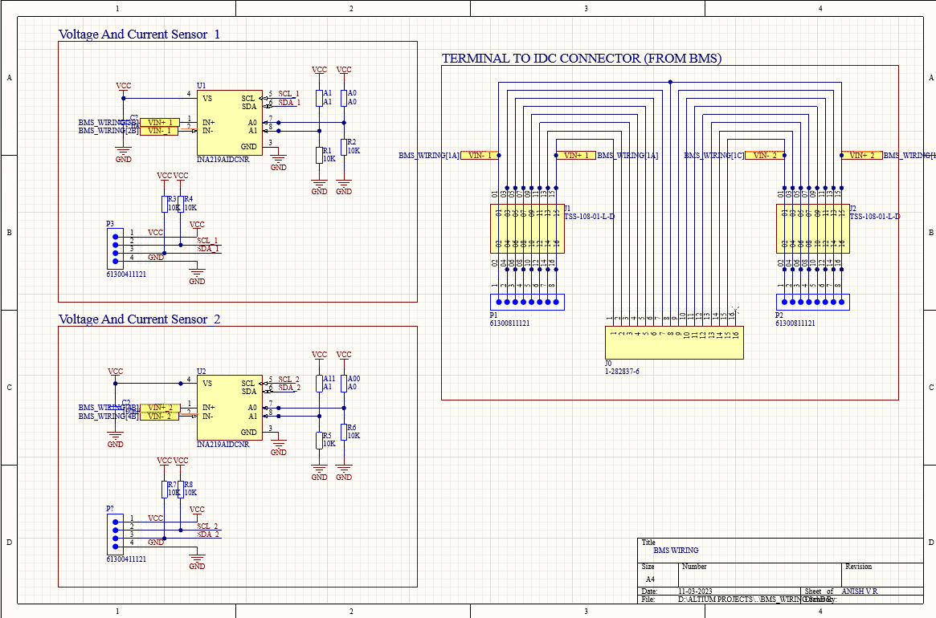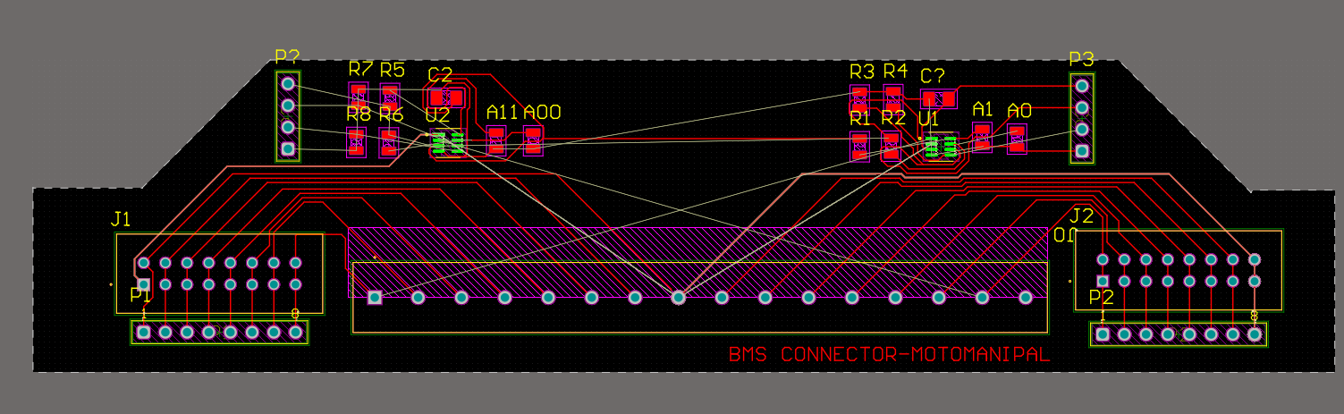I've set an ambitious timeline for myself, aiming to complete the PCB design within just three days, demonstrating my dedication to the project's progress.

